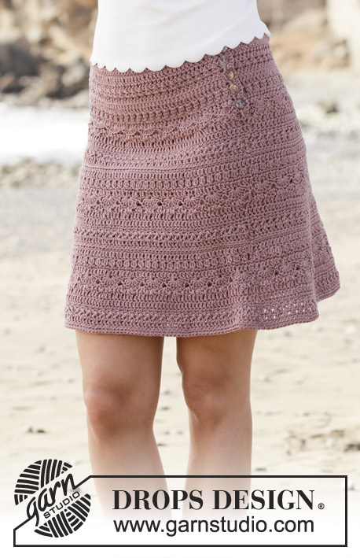

Rosalina by DROPS Design

Skirt with fan pattern, crocheted top down. Size: S - XXXL Piece is crocheted in DROPS Muskat.
Tags: fan pattern, skirts, top down,
DROPS design: Pattern r-729
Yarn group B
----------------------------------------------------------
Size: S - M - L - XL - XXL - XXXL
Materials:
DROPS MUSKAT from Garnstudio (belongs to yarn group B)
350-400-450-500-550-600 g color 09, light brown
Piece can also be crocheted with yarn from:
“Alternative yarn (yarn group B)” - see link below.
DROPS CROCHET Hook size 4 mm / G/6 - or size needed to get 18 double crochets x 9 rows = 10 cm / 4'' in width and 10 cm / 4'' vertically.
DROPS MOTHER-OF-PEARL BUTTON ARCHED (white), NO 521: 5 pieces for all sizes

attern instructions
NOTE: This pattern is written in American English. All measurements in charts are in cm. For conversion from inches to cm - click here. There are different terms for crocheting in American and British English. If this pattern includes crochet, click for "crochet terms" here. For this pattern in British English, please click here.
INFORMATION FOR PATTERN:
PATTERN:
See diagrams A.1 and A.2. Diagram A.1 shows how every row/round begins and ends (i.e. when working back and forth do not work 1 slip stitch in chain stitch at beginning of row).
CROCHET INFO:
At beginning of every row with double crochets work 3 chain stitches (do not replace first double crochet).
At beginning of every row with single crochets work 1 chain stitch (does not replace first single crochet).
INCREASE TIP:
Increase on row/round 1, 4, 7, 11 and 12 in pattern A.2b (i.e. increase 6 stitches evenly 5 times in total per repetition of A.2b in height).
Increase by working 2 double crochets in/around in same stitch. To calculate how often increase should be done on round, use the total number of stitches on row/round (e.g. 132 double crochets) and divide by number of increases to be done (e.g. 6) = 22. I.e. in this example increase 1 double crochet in/around/between every 22nd stitch.
----------------------------------------------------------

SKIRT:
Work top down. Work back and forth until vent in the side is done, then work in the round.
Work 142-156-170-184-212-233 chain stitches (including 3 chain stitches to turn with) on hook size 4 mm / G/6 with Muskat.
Work first row as follows: Work 1 double crochet in 4th chain stitch from hook (= 1 double crochet) - read CROCHET INFO, 1 double crochet in each of the next 5 chain stitches, * skip 1 chain stitch, 1 double crochet in each of the next 6 chain stitches *, work from *-* = 120-132-144-156-180-198 double crochets.
Work 1 row with 1 double crochet in every double crochet.
Work A.2a 20-22-24-26-30-33 times in total in width.
When A.2a has been worked, work A.2b over A.2a (first row in A.2b is from wrong side) and increase as follows (i.e. increase on first round and A.2b is repeated in height):
REMEMBER THE CROCHET GAUGE! Increase 6 double crochets evenly - read INCREASE TIP - 16-16-17-18-18-20 times in total = 216-228-246-264-288-318 stitches.
For every increase work 1 more repetition of A.2b in width AT THE SAME TIME when piece measures 11 cm, end the vent in the side and continue piece in the round, begin round in the side.
Fasten off when piece measures 38-40-42-44-46-48 cm / 15''-15¾''-16½''-17¼''-18''-19'', finish neatly according to pattern.
EDGE AT THE TOP:
Work 1 single crochet in every chain stitch where double crochets were worked in on first row =
120-132-144-156-180-198 single crochets. Work 3 rows in total with single crochets. Fasten off.
BUTTONHOLE LOOPS:
Along the opening on front piece work buttonhole loops (start at the bottom).
Work 2 single crochets around every double crochet row and 1 single crochet around every single crochet row as follows: Work 1 slip stitch around first row, 3 chain stitches, skip 1 cm / 3/8'', * work single crochets around next double crochet/single crochet row, 3 chain stitches, skip approx. 1 cm / 3/8'' *, work from *-* 4 times in total and finish with 2 single crochets around the last 2 single crochet rows at the top,
turn and work back as follows: 1 single crochet in every single crochet and 3 single crochets in every chain space. Fasten off.
BUTTON FOLDING EDGE:
Along the other side of opening work 5 rows with 1 single crochet in every single crochet back and forth (on 1st row work 2 single crochet around every double crochet row and 1 single crochet around every single crochet row), fasten off. Sew the buttons on to the button folding edge.

Diagram
All measurements in charts are in cm.
= chain stitch
= single crochet in stitch
= single crochet in back loop of stitch from right side and in front loop of stitch from wrong side
= single crochet around chain stitch
= double crochet in stitch
= double crochet between 2 double crochets
= double crochet around chain stitch
= skip 1 double crochet, work 1 double crochet in/around next double crochet/chain stitch, 1 double crochet in stitch that was skipped
= double crochet group: Work 1 double crochet in next double crochet but wait with last pull through (= 2 loops on hook), work 2 double crochets in same double crochet the same way, pull yarn through all 4 loops on hook
= 1 treble crochet in first/last single crochet in the fan 2 rows down (make sure to at the same time work around the chain stitch on the row in the middle)
= increase evenly - see pattern
= first row is not worked, it has already been worked, it only shows how next row should be worked in stitches
= row begins with 3 chain stitches, round begins with 3 chain stitches and ends with 1 slip stitch in first stitch in A.2
= row begins with 1 chain stitch, round begins with 1 chain stitch and ends with 1 slip stitch in first stitch in A.2
